Báo cáo thực hành lab01

Trần Anh

20215179 - ICT k66-01

2.2.1 Write, compile the first Java application:

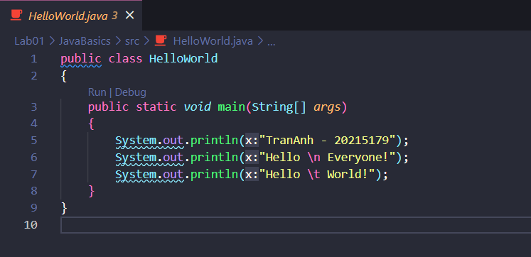

kết quả

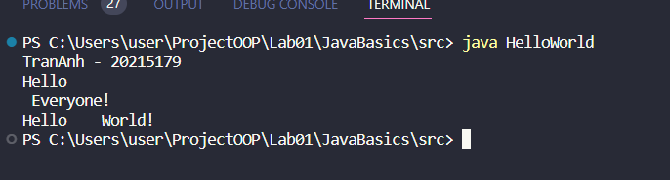

2.2.2 Write, compile the first dialog Java program

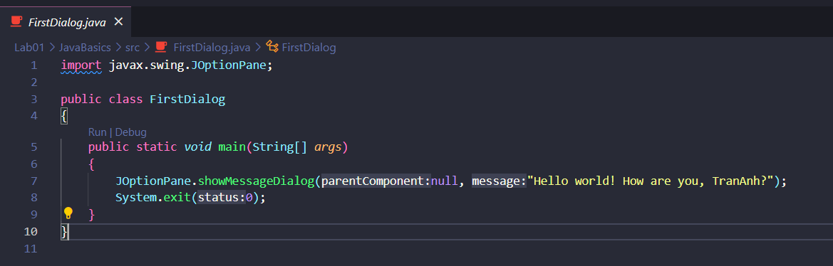

kết quả

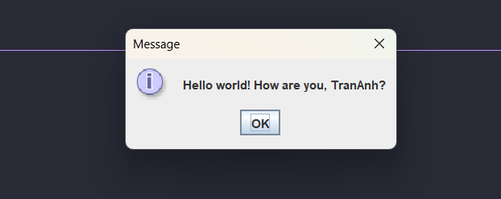

2.2.3 Write, compile the first input dialog Java application

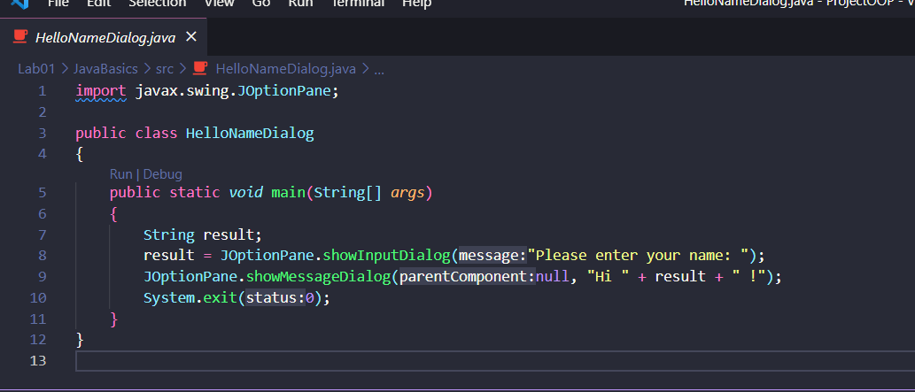

kết quả

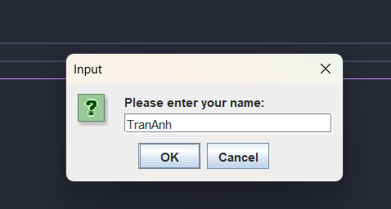

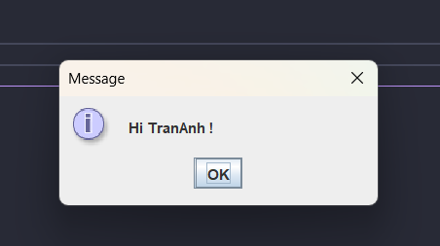

2.2.4 Write, compile, and run the following example:

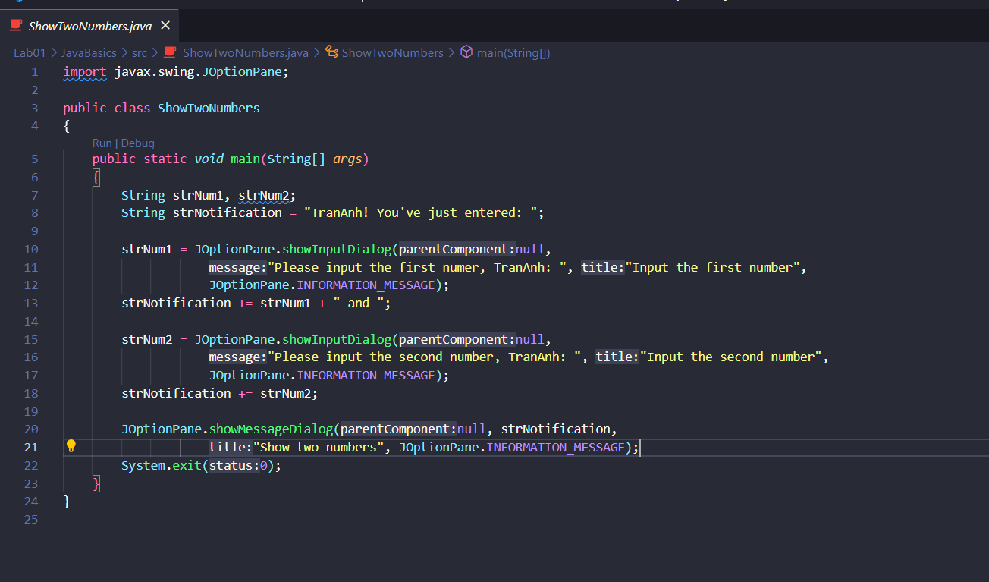

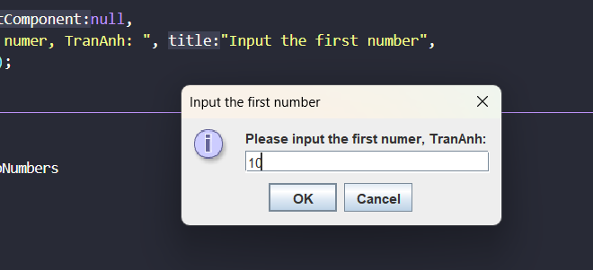

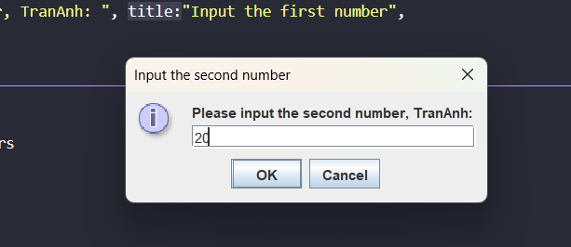

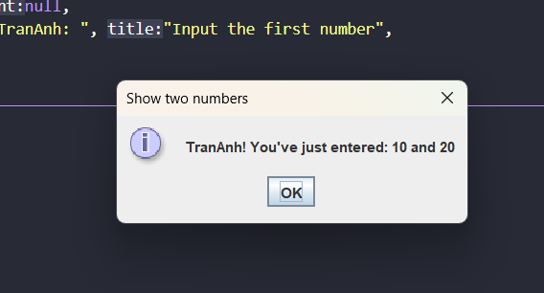

kết quả

2.2.5 Write a program to calculate sum, difference, product, and quotient of 2 double numbers which are entered by users

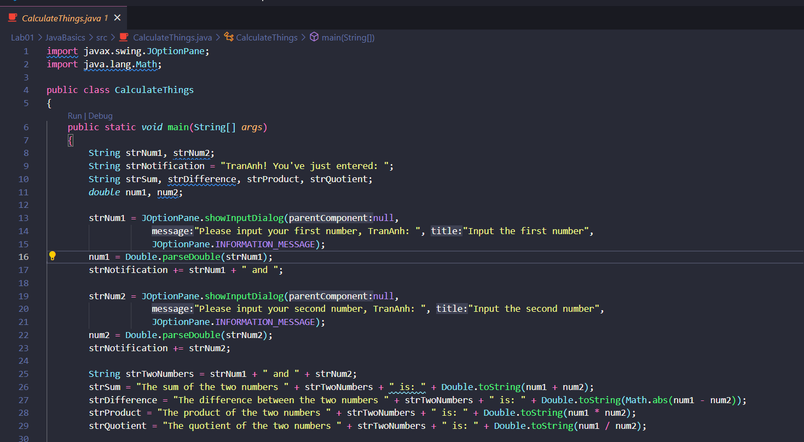

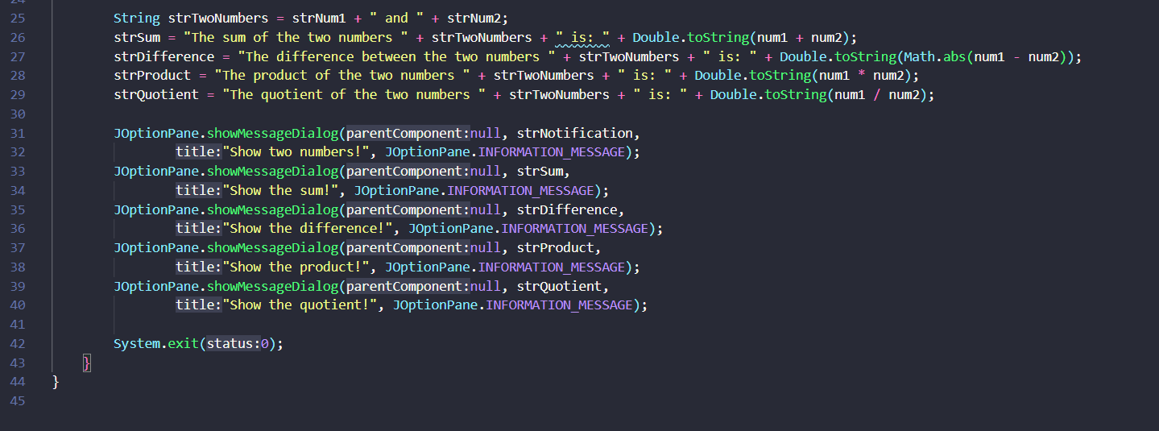

kết quả

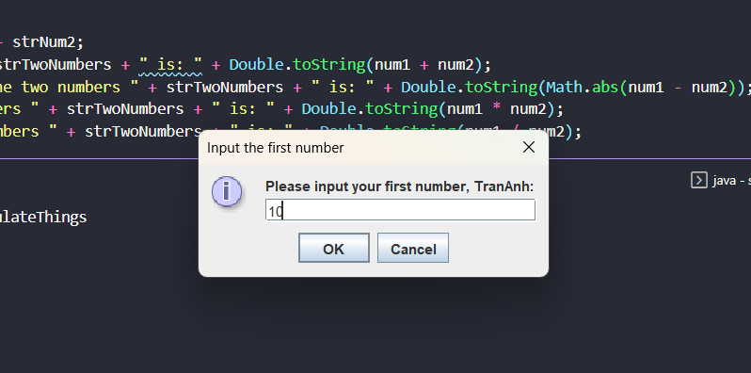

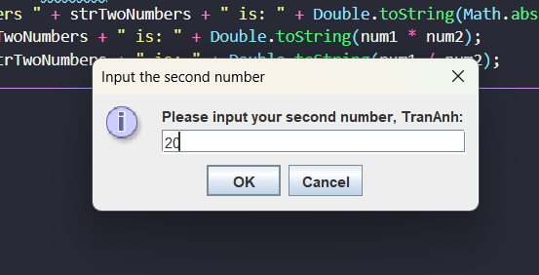

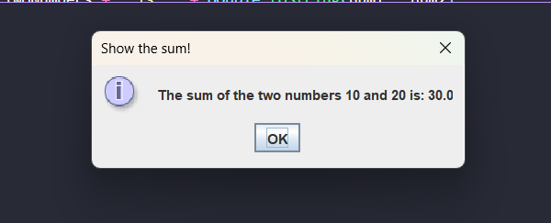

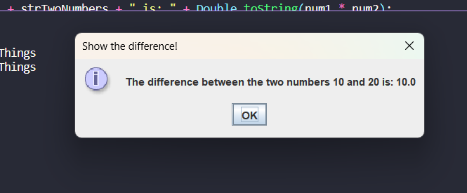

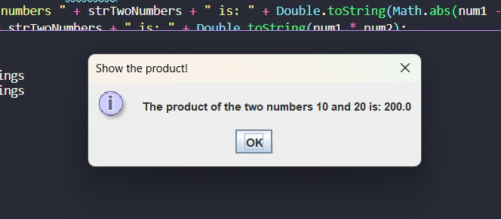

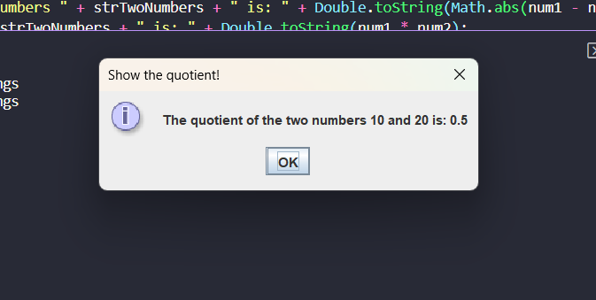

2.2.6 Write a program to solve:

* The first-degree equation (linear equation) with one variable
* The system of first-degree equations (linear system) with two variables
* The second-degree equation with one variable

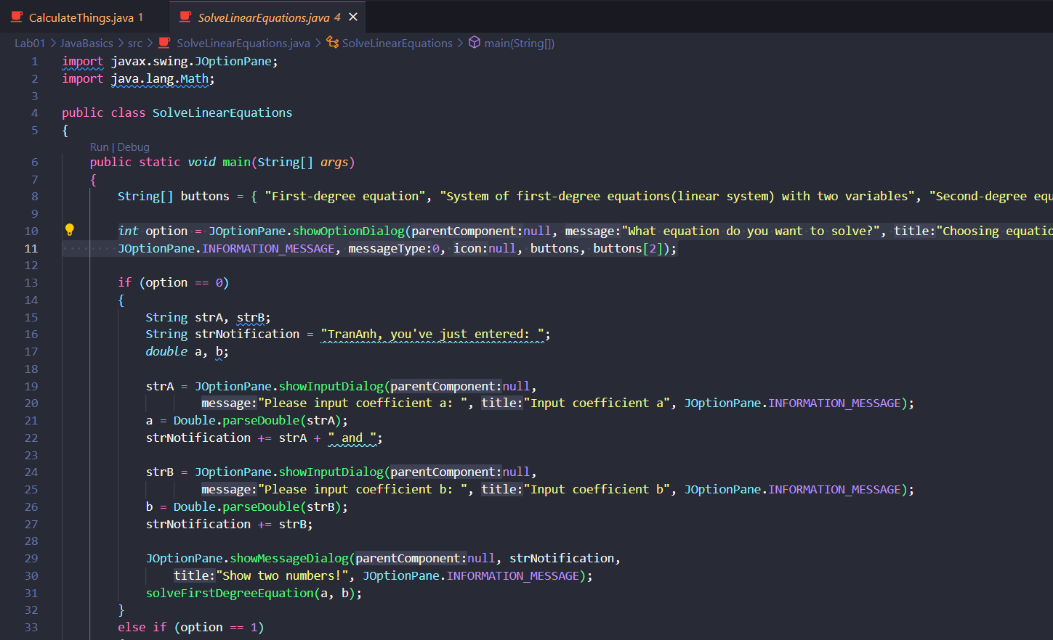

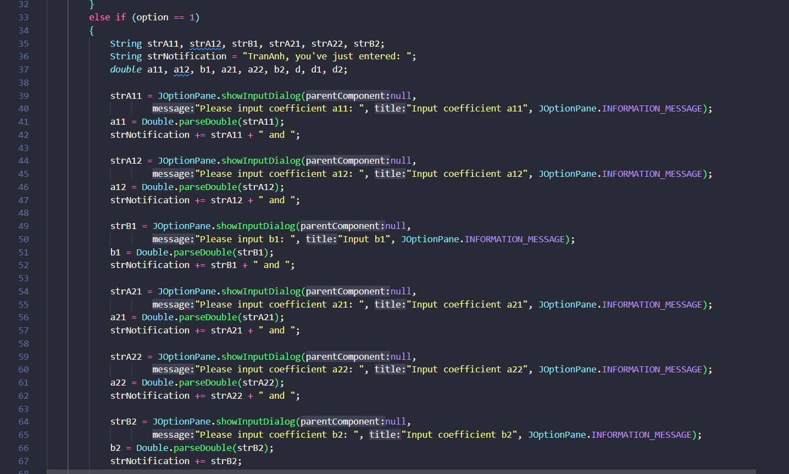

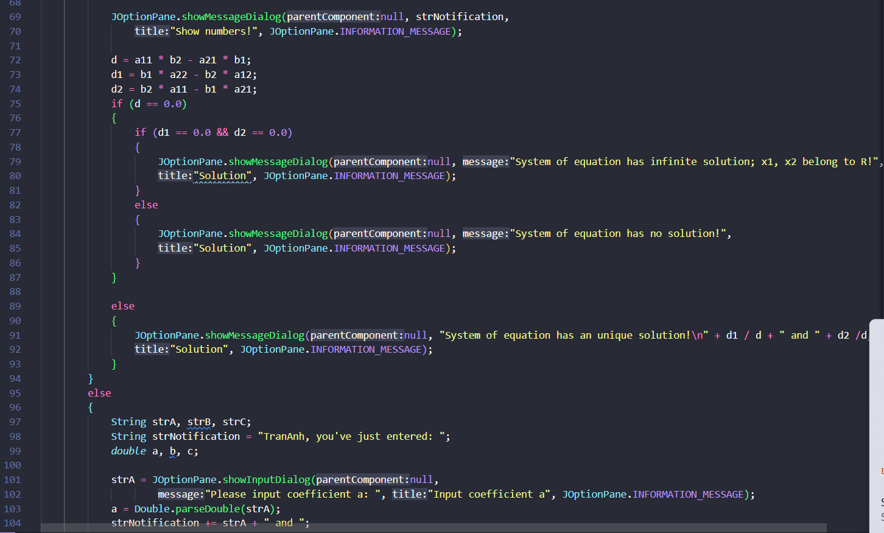

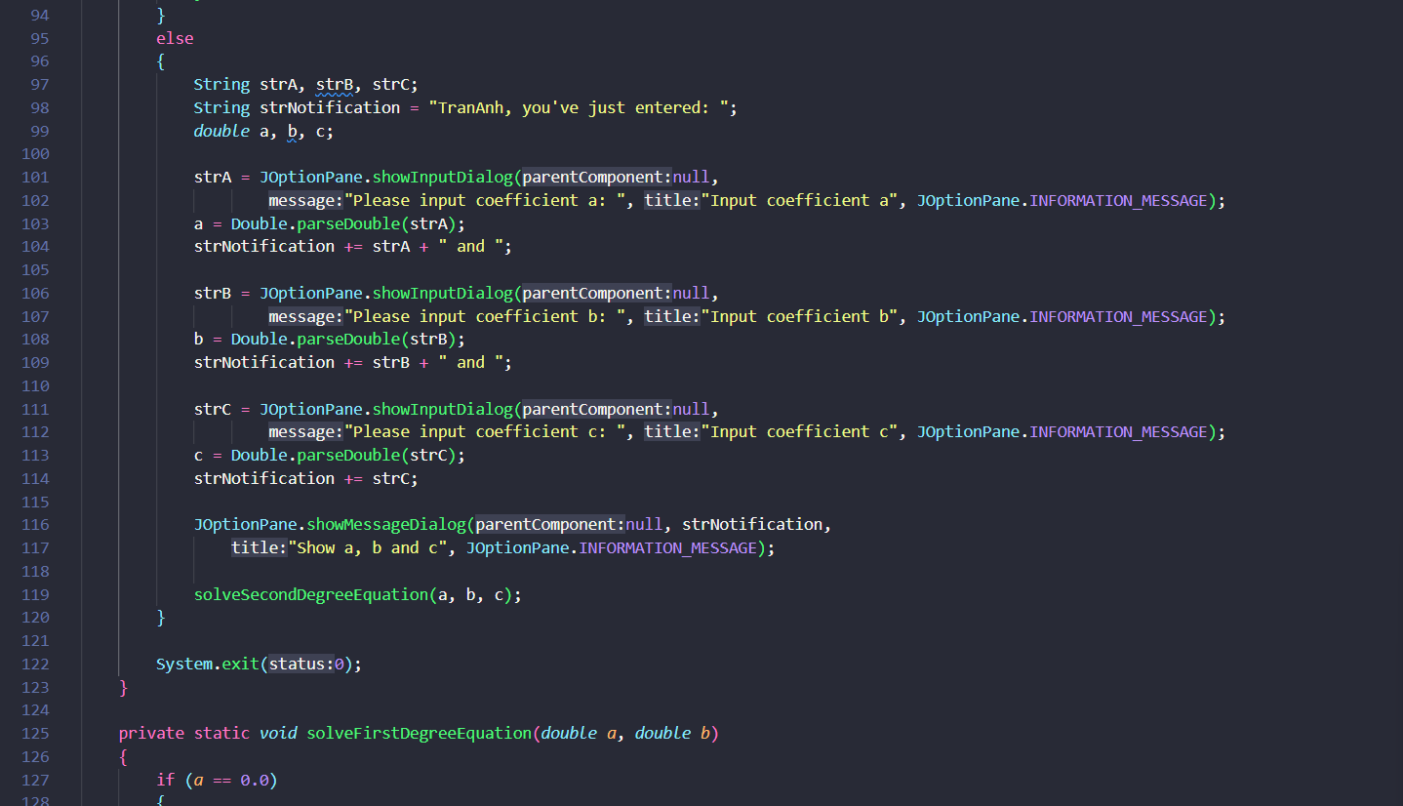

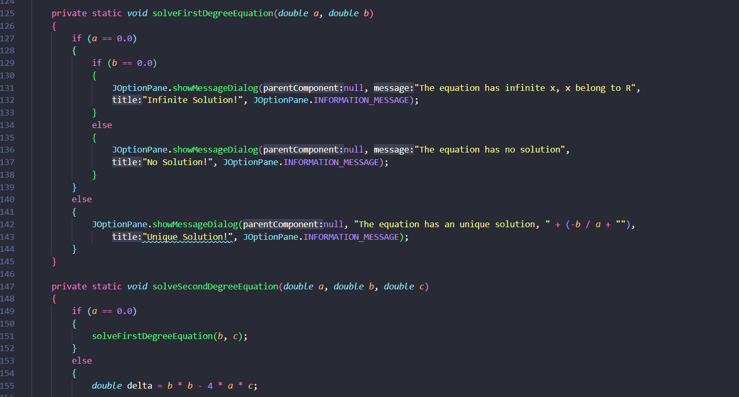

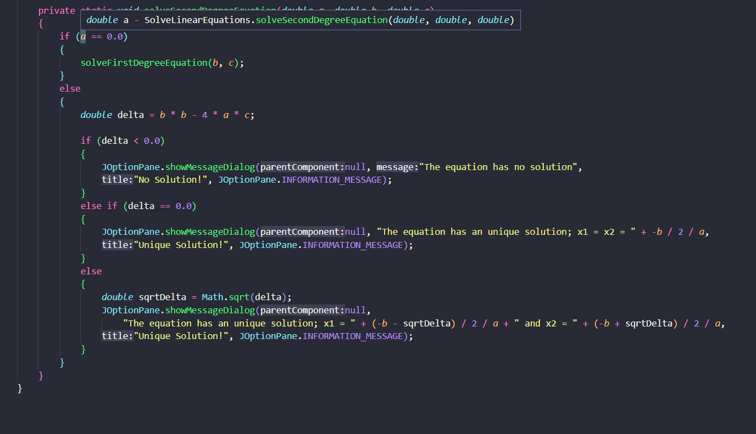

kết quả

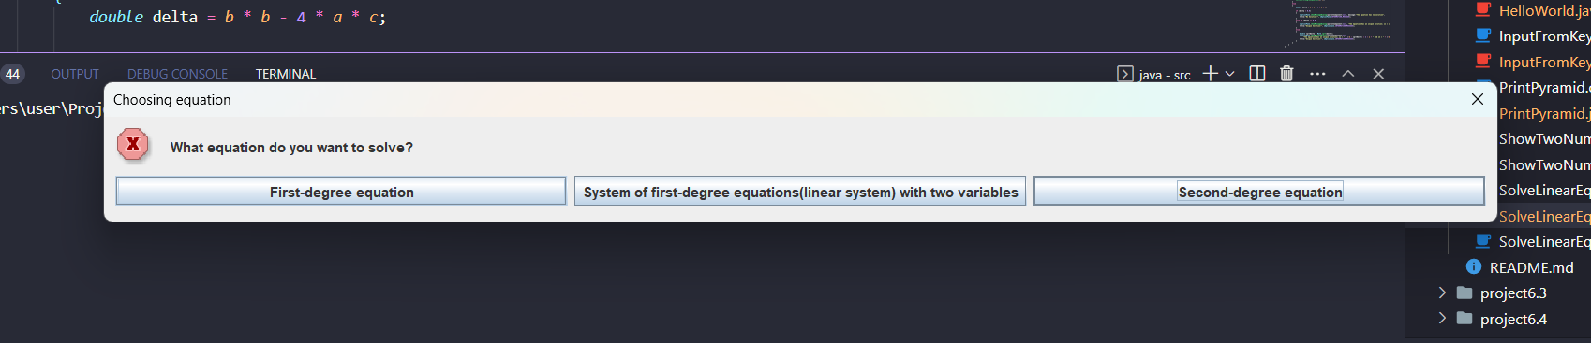

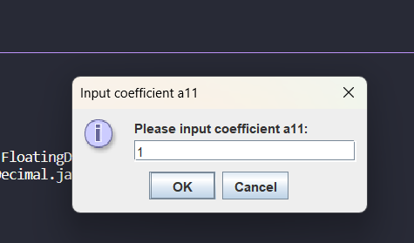

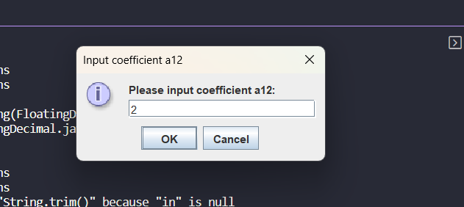

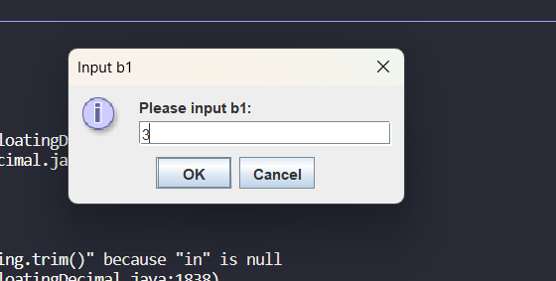

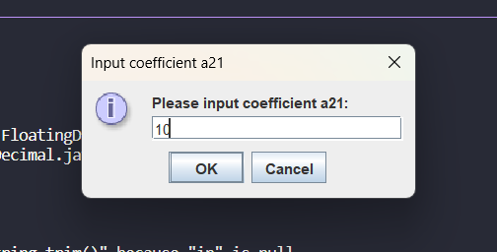

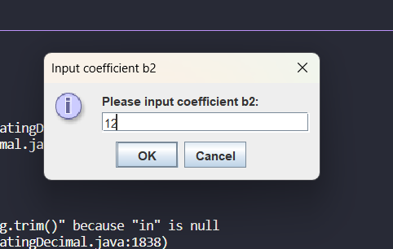

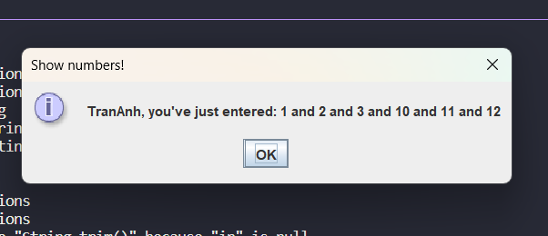

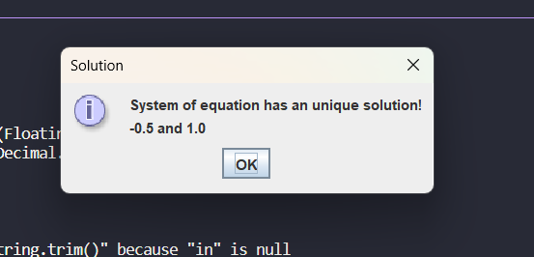

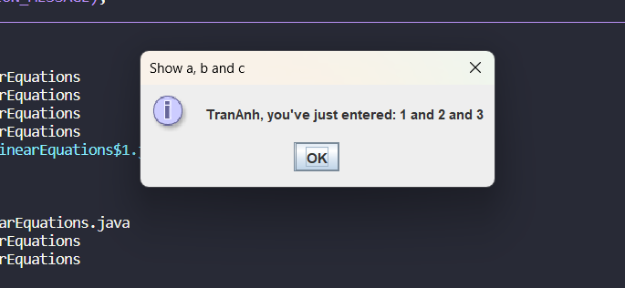

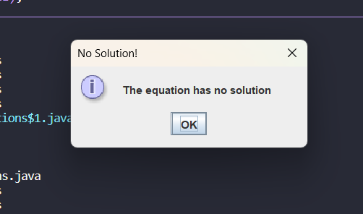

6.1 Write, compile and run the ChoosingOption program:

Note: We use JavaBasics project for this exercise.

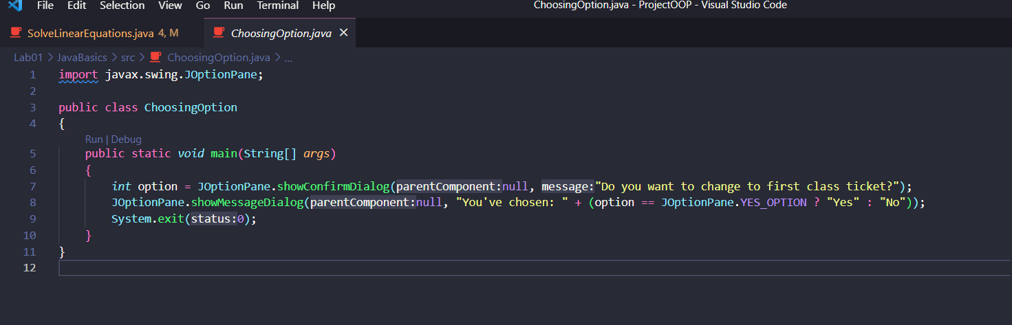

kết quả

Question:

* What happens if users choose “Cancel” -> It displays like in the case you choose No
* How to customize the options to users, e.g. only two options: “Yes” and “No”, OR “I do” and “I don’t” (Suggestion: Use Javadocs or using Eclipse/Netbean IDE help).

-> Use another approach

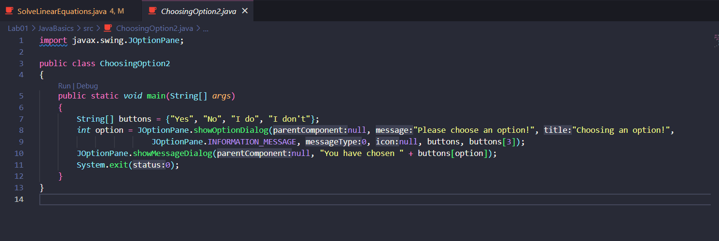

6.2 Write a program for input/output from keyboard

Note: We use the JavaBasics project for this exercise.

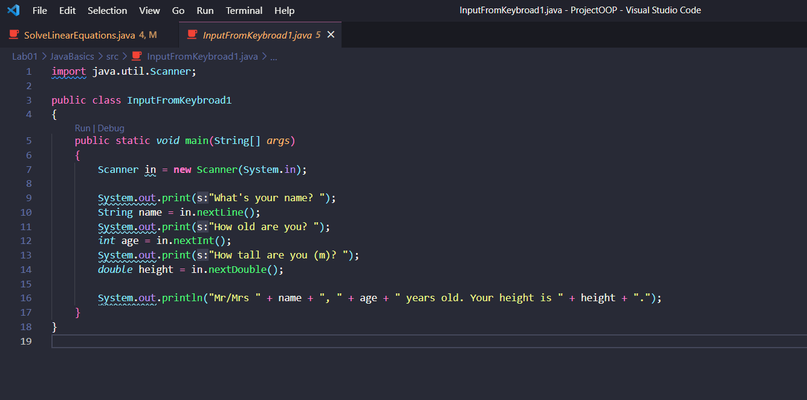

kết quả

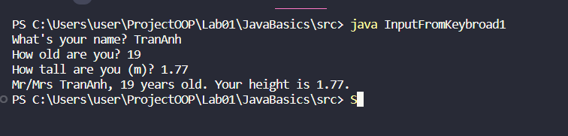

6.3 Write a program to display a triangle with a height of n stars (*), n is entered by users.

Note: You must create a new Java project for this exercise.

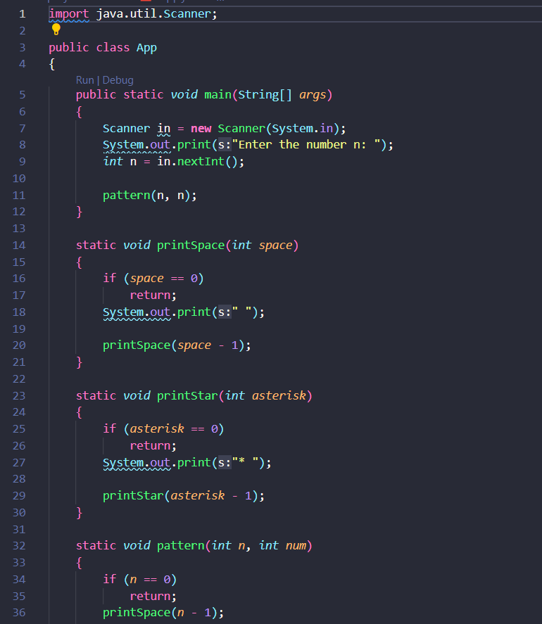

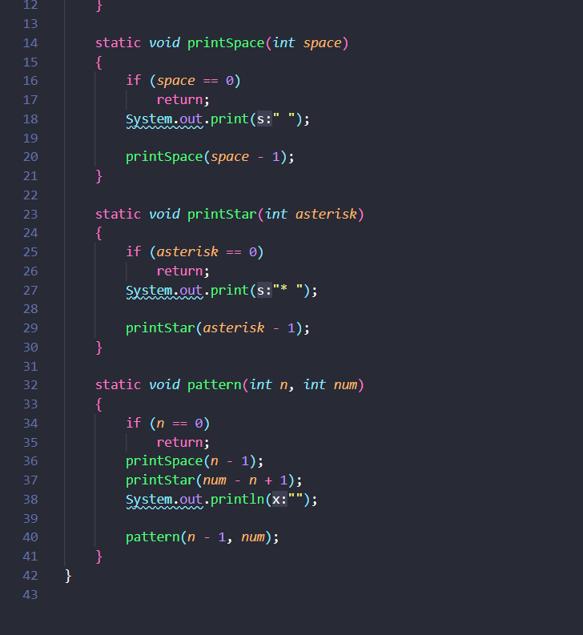

kết quả

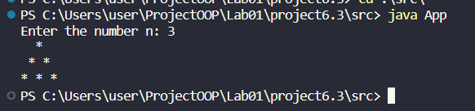

6.4 Write a program to display the number of days of a month, which is entered by users (both month and year). If it is an invalid month/year, ask the user to enter again.

Note: You must create a new Java project for this exercise.

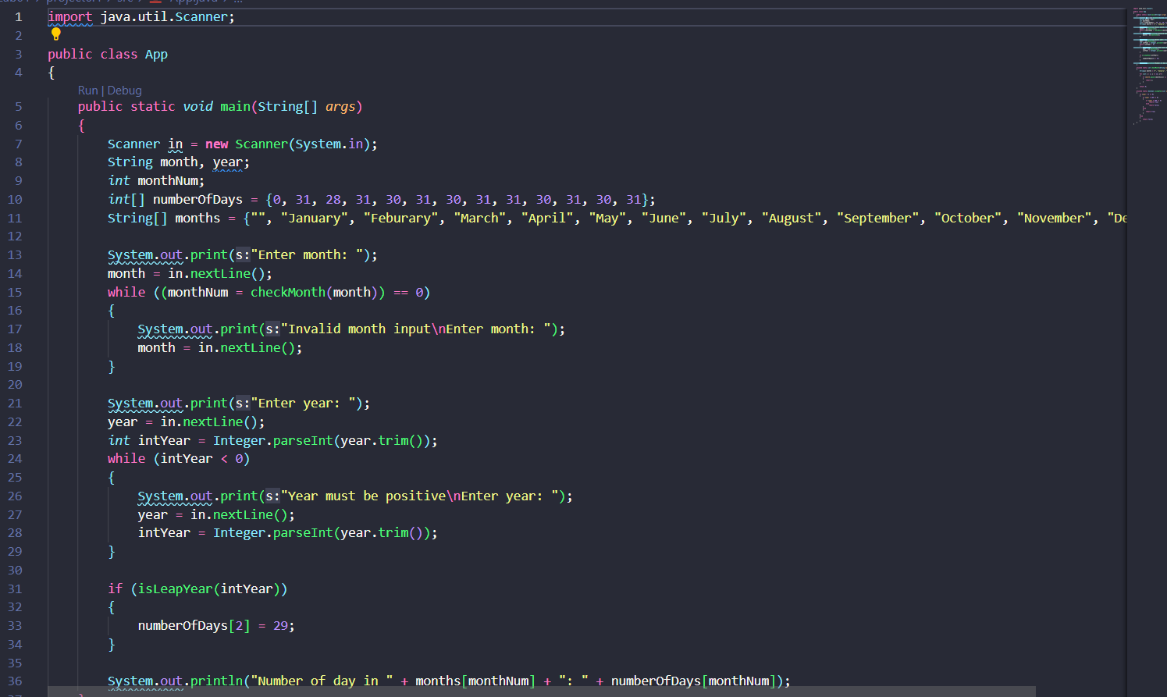

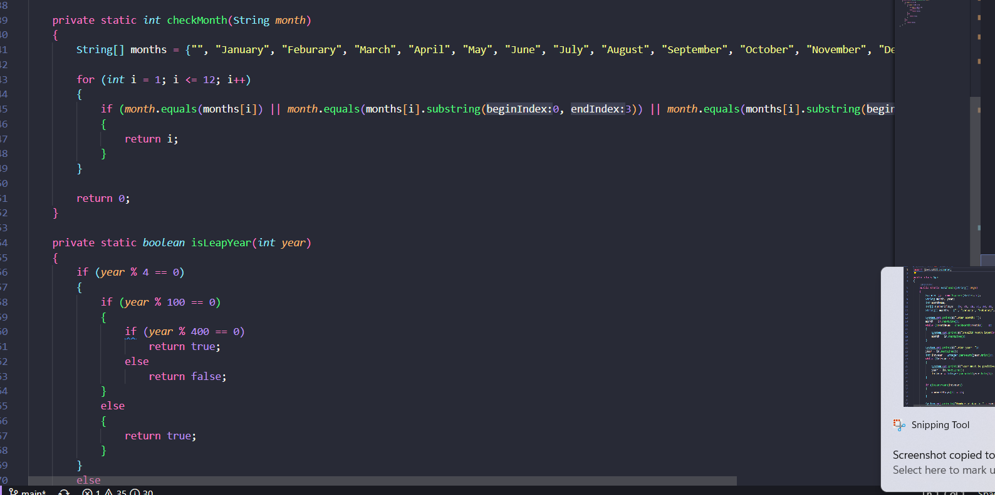

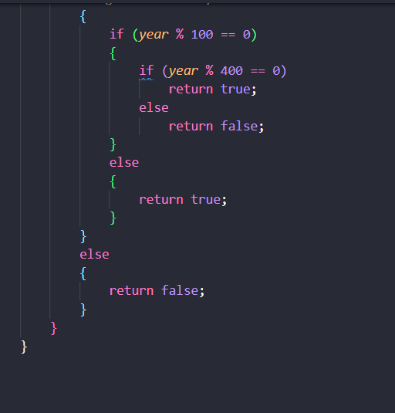

kết quả

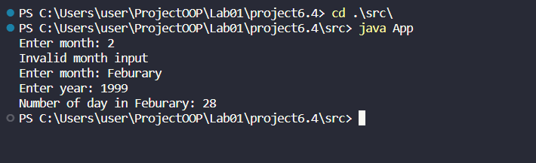

6.5 Write a Java program to sort a numeric array, and calculate the sum and average value of array elements.

Note: You must create a new Java project for this exercise.

- The array can be entered by the user or a constant.

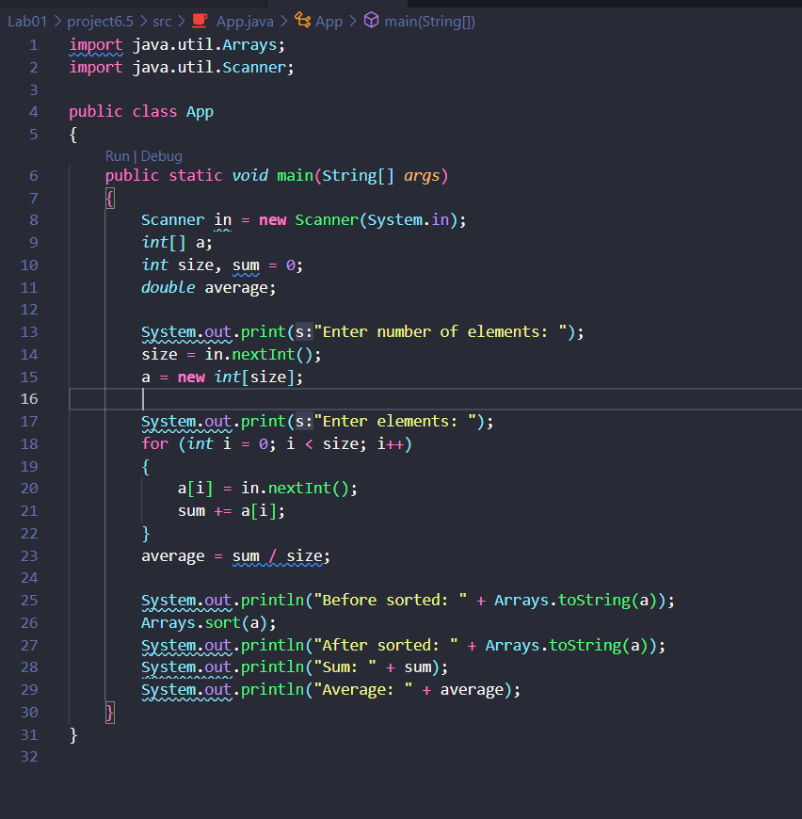

kết quả

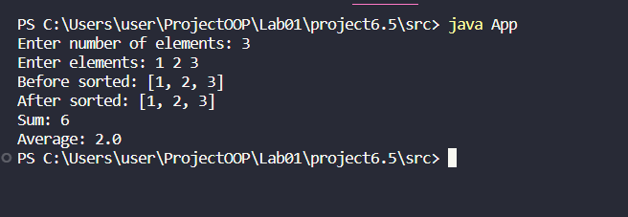

6.6 Write a Java program to add two matrices of the same size.

Note: You must create a new Java project for this exercise.

- The matrices can be entered by the user or constants.

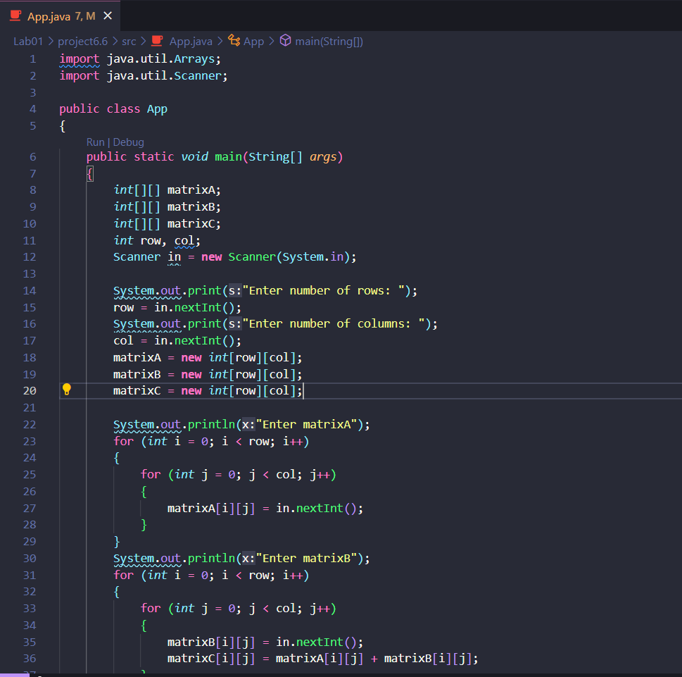

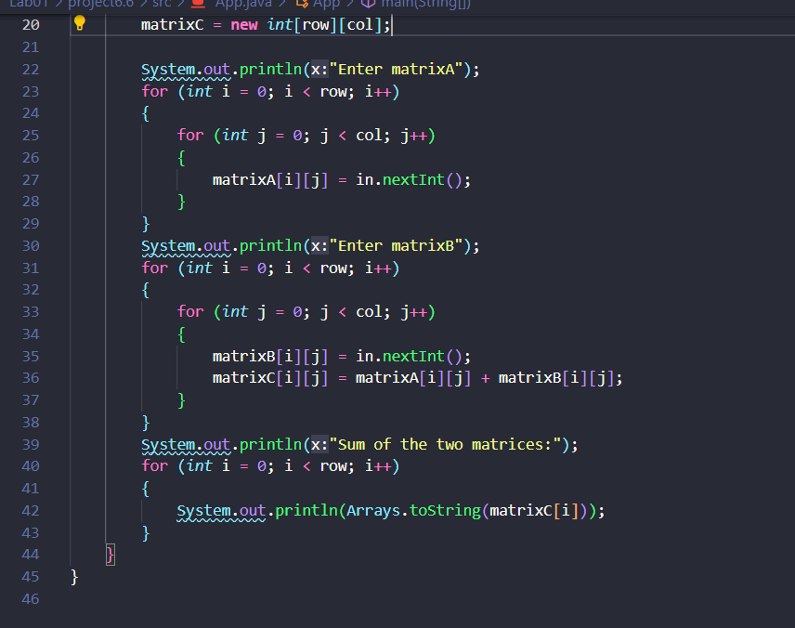

kết quả

